CHAPTER 18

Financial Analysis: The Big Picture

ASSIGNMENT CLASSIFICATION TABLE

Learning Objectives |  | Questions |  | Brief  Exercises |  | Do It! |  | Exercises |  | A  Problems
*1. Apply the concepts of sustainable income and quality of earnings. |  | 1, 2, 3, 4, 5, 6 |  | 1, 2, 3 |  | 1 |  | 1, 2
*2. Apply horizontal analysis and vertical analysis. |  | 7, 8, 10 |  | 4, 5, 6, 7, 8, 9 |  | 2 |  | 3, 4, 5, 6 |  | 1A
*3. Analyze a company’s performance using ratio analysis. |  | 9, 11, 12, 13, 14, 15, 16, 17, 18, 19, 20, 21, 22 |  | 10, 11, 12, 13, 14, 15 |  | 3 |  | 7, 8, 9, 10, 11, 12, 13 |  | 1A, 2A, 3A, 4A, 5A

ASSIGNMENT CHARACTERISTICS TABLE

Problem  Number |  | Description |  | Difficulty  Level |  | Time  Allotted (min.)
1A |  | Prepare vertical analysis and comment on profitability. |  | Moderate |  | 20–30
2A |  | Compute ratios from balance sheets and income  statements. |  | Moderate |  | 20–30
3A |  | Perform ratio analysis, and discuss changes in  financial position and operating results. |  | Moderate |  | 20–30
4A |  | Compute ratios; comment on overall liquidity and  profitability. |  | Moderate |  | 40–50
5A |  | Compute selected ratios, and compare liquidity,  profitability, and solvency for two companies. |  | Moderate |  | 50–60

ANSWERS TO QUESTIONS

1. Sustainable income is defined as the most likely level of income to be obtained in the future. It is the amount of regular income that a company can expect to earn from its normal operations.
In order to distinguish a company’s net income from its sustainable income, irregular items, such as discontinued operations, are reported separately on the income statement.
LO 1 BT: C Difficulty: Easy TOT: 2 min. AACSB: None AICPA FC: Reporting IMA: Reporting

2. This would not be considered a favorable trend for Hogan Inc. The relevant earnings per share figures are the $3.26 in 2019 and the $2.99 in 2020. These figures indicate that, unless there was an additional issuance of common stock, the earnings from the continuing operations of the company decreased during 2020. This should give the company’s management some concern because they will not always be able to rely on income or gains from unusual items such as discontinued operations.
LO 1 BT: C Difficulty: Moderate TOT: 4 min. AACSB: Analytic AICPA FC: Reporting IMA: Reporting and FSA

3. Companies report a change from FIFO to average cost pricing for inventory retroactively. That is, they report both the current period and any previous periods reported on the face of the financial statements using the new principle. As a result, the same principle applies in all periods. This treatment improves the ability to compare results across years.
LO 1 BT: C Difficulty: Easy TOT: 3 min. AACSB: None AICPA FC: Reporting IMA: Reporting

4. Apple reported “Other comprehensive loss” of $1,427 million for the year ended September 26, 2015. “Comprehensive income” was less than “Net income” by 2.7% [($51,967 – $53,394) ÷ $53,394]
LO 1 BT: AP Difficulty: Easy TOT: 3 min. AACSB: Analytic AICPA FC: Reporting IMA: Reporting

5. (1) Use of alternative accounting methods. Variations among companies in the application of generally accepted accounting principles may hamper comparability.

(2) Use of pro forma income measures that do not follow GAAP. Pro forma income is calculated by excluding items that the company believes are unusual or nonrecurring. It is often difficult to determine what was included and excluded.

(3) Improper revenue and expense recognition. Many high-profile cases of inappropriate accounting involve recording items in the wrong period.
LO 1 BT: C Difficulty: Easy TOT: 5 min. AACSB: None AICPA FC: Reporting IMA: Reporting

6. (a) During a period of inflation, net income will be less under the LIFO inventory costing method than it will be using the FIFO method because LIFO results in the larger cost of goods sold amount.

(b) Inflation does not affect the amount of depreciation taken (except through its effect on salvage) since the depreciable amount is based on the acquisition cost. A six-year life produces greater depreciation for the first six years (thus, less net income) and less depreciation in years 7, 8, 9 (thus, more net income in those years) than a nine-year life.

(c) Inflation does not affect the amount of depreciation taken. Use of the straight-line method results in less depreciation in the earlier years (thus, more net income) than the declining-balance method but more depreciation in the later years.
LO 1 BT: C Difficulty: Moderate TOT: 6 min. AACSB: None AICPA FC: Reporting IMA: Reporting

Questions Chapter 18 (Continued)
7. Horizontal analysis (also called trend analysis) measures the dollar and percentage increase or
decrease of an item over a period of time. In this approach, the amount of the item on one statement is compared with the amount of that same item on one or more earlier statements. Vertical analysis, also called common-size analysis, expresses each item within a financial statement as a percent of a relevant base amount, such as net sales on the income statement and total assets on the balance sheet.
LO 2 BT: C Difficulty: Easy TOT: 3 min. Analytic AICPA FC: Reporting IMA: FSA

8. (a) $300,000 × 1.245 = $373,500, 2020 net income.
(b) $300,000 ÷ .06 = $5,000,000, 2019 revenue.
LO 2 BT: AP Difficulty: Easy TOT: 4 min. AACSB: Analytic AICPA FC: Reporting IMA: FSA

9. (a) Gina is not correct. There are three characteristics: liquidity, profitability, and solvency.

(b) The three parties are not primarily interested in the same characteristics of a company. Short- term creditors are primarily interested in the liquidity of the enterprise. In contrast, long-term creditors and stockholders are primarily interested in the profitability and solvency of the company.
LO 3 BT: C Difficulty: Easy TOT: 4 min. AACSB: None AICPA FC: Reporting IMA: FSA

10. (a) Comparison of financial information can be made on an intracompany basis, an intercompany basis, and an industry average basis.
1. An intracompany basis compares the same item with prior periods, or with other
financial items in the same period.
2. An intercompany basis compares the same item with other companies’ published reports.
3. The industry average compares the item with the industry average as compiled by Dun & Bradstreet or by trade associations.

(b) The intracompany basis of comparison is useful in detecting changes in financial relationships and significant trends within a company.
The intercompany basis of comparison provides insight into a company’s competitive position.
The industry average basis provides information about a company’s relative position within the industry.
LO 2 BT: K Difficulty: Moderate TOT: 8 min. AACSB: Analytic AICPA FC: Reporting IMA: FSA

11. (a) Liquidity ratios: Working capital, current ratio, inventory turnover, days in inventory, accounts receivable turnover, and average collection period.
(b) Solvency ratios: Debt to assets ratio, times interest earned, and free cash flow.
LO 3 BT: K Difficulty: Easy TOT: 3 min. AACSB: None AICPA FC: Reporting IMA: FSA

12. Tina is correct. A single ratio by itself may not be very meaningful and is best interpreted by comparison with (1) past ratios of the same company, (2) ratios of other companies, or (3) industry norms or predetermined standards. In addition, other ratios of the company are necessary to determine overall financial well-being.
LO 3 BT: C Difficulty: Easy TOT: 4 min. AACSB: Analytic AICPA FC: Reporting IMA: FSA

13. (a) Liquidity ratios measure the short-term ability of the company to pay its maturing obligations and to meet unexpected needs for cash.
(b) Solvency ratios measure the company’s ability to survive over a long period of time.
(c) Profitability ratios measure the income or operating success of a company for a given period of time.
LO 3 BT: C Difficulty: Easy TOT: 4 min. AACSB: None AICPA FC: Reporting IMA: FSA

Questions Chapter 18 (Continued)

14. Working capital and the current ratio both relate current assets to current liabilities. Working capital produces a dollar amount that indicates the difference between current assets and current liabilities. The current ratio produces a ratio which indicates the proportional relationship between current assets and current liabilities.
LO 3 BT: C Difficulty: Easy TOT: 2 min. AACSB: None AICPA FC: Reporting IMA: FSA

15. Handi Mart does not necessarily have a problem. The accounts receivable turnover can be
misleading in that some companies encourage credit and revolving charge sales and slow collections in order to earn a healthy return on the outstanding receivables in the form of high rates of interest.
LO 3 BT: C Difficulty: Easy TOT: 4 min. AACSB: Analytic AICPA FC: Reporting IMA: FSA

16. (a) Asset turnover.
(b) Inventory turnover and days in inventory.
(c) Return on common stockholders’ equity.
(d) Times interest earned.
LO 3 BT: C Difficulty: Easy TOT: 4 min. AACSB: None AICPA FC: Reporting IMA: FSA

17. The price-earnings (P-E) ratio is a reflection of investors’ assessments of a company’s future earnings. The P-E ratio takes into account such factors as relative risk, stability of earnings, trends in earnings, and the market’s perception of the company’s growth potential. In this question, investors favor Microsoft because it has the higher P-E ratio. The investors feel that Microsoft will be able to generate even higher future earnings and thus investors are
willing to pay more for the stock.
LO 3 BT: C Difficulty: Easy TOT: 4 min. AACSB: Analytic AICPA FC: Reporting IMA: FSA

18. The payout ratio is cash dividends declared on common stock divided by net income. In a growth company, the payout ratio is often low because the company is reinvesting earnings in the business.
LO 3 BT: C Difficulty: Easy TOT: 4 min. AACSB: None AICPA FC: Reporting IMA: FSA

19. (a) The increase in the profit margin is good news because it means that a greater percentage of net sales is going towards income.

(b) The decrease in inventory turnover signals bad news because it is taking the company longer to sell the inventory and consequently there is a greater chance of inventory obsolescence.

(c) An increase in the current ratio signals good news because the company improved its ability
to meet maturing short-term obligations.

(d) Earnings per share is a deceptive ratio. The decrease might be bad news to the company because it could mean a decrease in net income. Or the decrease might be good news to the company because of an increase in stockholders’ investment.

(e) The increase in the price-earnings ratio is generally good news because it means that the market price per share of stock has increased and investors are willing to pay that higher price for the stock.

(f) The increase in the debt to assets ratio is bad news because it means that the company has increased its obligations to creditors and has lowered its equity “buffer.”

Questions Chapter 18 (Continued)

(g) The decrease in the times interest earned is bad news because it means that the
company’s ability to meet interest payments as they come due has weakened.

LO 3 BT: C Difficulty: Easy TOT: 10 min. AACSB: None AICPA FC: Reporting IMA: FSA

20. | Return on assets | = | 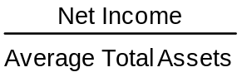 |  | = 7.6%
 | Return on common stockholders’ equity |  |  | = | 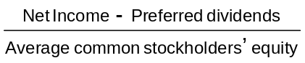= 12.8%
The difference between the two rates can be explained by looking at the denominator value and by remembering the basic accounting equation, A = L + SE. The asset value will clearly be the larger of the two denominator values; therefore, it will also give the smaller rate of return.
LO 3 BT: C Difficulty: Easy TOT: 4 min. AACSB: None AICPA FC: Reporting IMA: FSA

21. (a) Times interest earned, which is an indication of the company’s ability to meet interest charges, and the debt to assets ratio, which indicates the company’s ability to withstand losses without impairing the interests of creditors.

(b) The current ratio and accounts receivable turnover, which indicate a company’s liquidity and short-term debt-paying ability.

(c) The earnings per share of common stock and the return on common stockholders’ equity, both of which indicate the earning power of the investment.
LO 3 BT: C Difficulty: Easy TOT: 6 min. AACSB: None AICPA FC: Reporting IMA: FSA

22.  = Earnings per share.

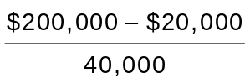 = $4.50

EPS of $4.50 is high relative to what? Is it high relative to last year’s EPS? The president may be comparing the EPS of $4.50 to the market price of the company’s stock, which is inappropriate.
LO 3 BT: AP Difficulty: Easy TOT: 4 min. AACSB: Analytic AICPA FC: Reporting IMA: FSA

SOLUTIONS TO BRIEF EXERCISES

BRIEF EXERCISE 18-1

FLORES CORPORATION
Partial Income Statement

Discontinued operations: Loss on disposal of
Mexico facility, net of $160,000
($640,000 x 25%) tax savings ($480,000)
[Loss on disp. = Loss × (1 − Tax rate)]; [$640,000 x (1 – 25%)]
LO 1 BT: AP Difficulty: Easy TOT: 4 min. AACSB: Analytic AICPA FC:Reporting IMA: Reporting

BRIEF EXERCISE 18-2

SILVA CORPORATION
Partial Statement of Comprehensive Income

Income before income taxes $450,000
Income tax expense ($450,000 x 25%) 112,500
Net Income 337,500
Other comprehensive income
Unrealized holding gain on available-for-sale securities,
net of $17,500 income taxes ($70,000 x 25%)………… 52,500
Comprehensive income $390,000
[Unreal. holding gain = Gain × (1 − Tax rate)]; [$70,000 x (1 – 25%)]
LO 1 BT: AP Difficulty: Moderate TOT: 6 min. AACSB: Analytic AICPA FC: Reporting IMA: Reporting

BRIEF EXERCISE 18-3

The change in inventory pricing for Bryce should be reported retroactively. That is, it should report both the current period and previous periods included on the face of the financial statements using the new principle. As a result, the same principle applies in all periods. The treatment improves the ability to compare results across years.
LO 1 BT: C Difficulty: Easy TOT: 4 min. AACSB: None AICPA FC: Reporting AICPA PC: Communication IMA: Reporting
BRIEF EXERCISE 18-4

Horizontal analysis:
Increase
or (Decrease)
 |  | Dec. 31, 2020 |  | Dec. 31, 2019 |  | Amount |  | Percentage*
Accounts receivable  Inventory  Total assets |  | $ 460,000  780,000  3,164,000 |  | $ 400,000  650,000  2,800,000 |  | $ 60,000  130,000  364,000 |  | 15%  20%  13%

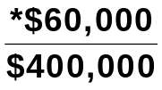 = 0.15 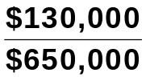 = 0.20 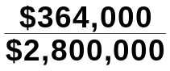 = 0.13
[Percent. change in 2020 Accts. rec. = (2020 bal. − 2019 bal) ÷ 2019 bal]; [($460,000 - $400,000) ÷ $400,000]
LO 2 BT: AP Difficulty: Moderate TOT: 6 min. AACSB: Analytic AICPA FC: Measurement and Reporting IMA: FSA

BRIEF EXERCISE 18-5

Vertical analysis:
 |  | Dec. 31, 2020 |  |  |  | Dec. 31, 2019
 |  | Amount |  | Percentage* |  | Amount |  | Percentage**
Accounts receivable  Inventory  Total assets |  | $ 460,000  780,000  3,164,000 |  | 14.5%  24.7%  100% |  | $ 400,000  650,000  2,800,000 |  | 14.3%  23.2%  100%

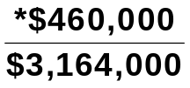 = 0.145 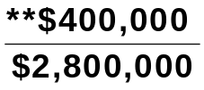 = 0.143

*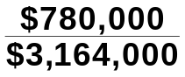 = 0.247 **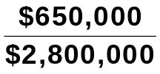 = 0.232
(2020 Accts. rec. percent. = Accts. rec. ÷ Tot. assets); ($460,000 ÷ $3,164,000)
LO 2 BT: AP Difficulty: Moderate TOT: 6 min. AACSB: Analytic AICPA FC: Measurement and Reporting IMA: FSA

BRIEF EXERCISE 18-6

 |  | 2020 |  | 2019 |  | 2018
Net income |  | $518,400 |  | $485,000 |  | $500,000

 |  |  | Increase or (Decrease)
 |  |  | Amount |  | Percentage*
(a)  (b) | 2018–2019  2019–2020 |  | ($15,000)  $33,400) |  | (3.0%)  6.9%)

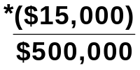 = (0.03) 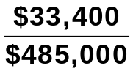 = 0.069
[Percent. change in 2019 = (2019 net. Inc. − 2018 net inc.) ÷ 2018 net inc.]; [($485,000 - $500,000) ÷ $500,000]
LO 2 BT: AP Difficulty: Moderate TOT: 5 min. AACSB: Analytic AICPA FC: Measurement and Reporting IMA: FSA

BRIEF EXERCISE 18-7

 |  | 2020 |  | 2019 |  | Increase
Net income |  | $382,800 |  | X |  | 16%

0.16 = 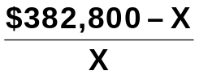
0.16X = $382,800 – X
1.16X = $382,800
X = $330,000

2019 Net Income = $330,000
(% increase in net income = ($382,800 – 2019 net income) ÷ 2019 net income)
LO 2 BT: AN Difficulty: Moderate TOT: 5 min. AACSB: Analytic AICPA FC: Measurement and Reporting IMA: FSA

BRIEF EXERCISE 18-8

 |  | 2020 |  | 2019 |  | 2018
Sales revenue  Cost of goods sold  Expenses  Net income |  | 100.0%  60.5  26.0  13.5% |  | 100.0%  62.9  26.6  10.5% |  | 100.0%  64.8  27.5  7.7%

Net income as a percent of sales for Palau increased over the three-year period because cost of goods sold and expenses both decreased as a percent of sales every year.
(Net inc. percent. = Sales rev. percent − CGS percent − Exp. percent)
LO 2 BT: AP Difficulty: Easy TOT: 4 min. AACSB: Analytic AICPA FC: Measurement and Reporting IMA: FSA

BRIEF EXERCISE 18-9

Comparing the percentages presented results in the following conclusions: The net income for Phoenix increased in 2019 because of the combination of an increase in sales and a decrease in both cost of goods sold and expenses. However, the reverse was true in 2020 as sales decreased, while both cost of goods sold and expenses increased. This resulted in a decrease in net income.
LO 2 BT: AN Difficulty: Moderate TOT: 5 min. AACSB: Analytic and Communication AICPA FC: Reporting AICPA PC: Communication IMA: FSA

BRIEF EXERCISE 18-10

Current ratio:
2020 2019
 = 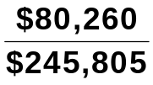 = .33:1 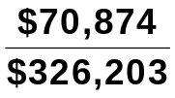 =.22:1

The current ratio increased by 50% (.33 ÷.22) indicating that Bob Evans Farms is more liquid in 2020. However, it is very low both years, indicating a liquidity problem.
(Current assets ÷ Current liabl.); (2020: $80,260 ÷ $245,805)
LO 3 BT: AP Difficulty: Easy TOT: 4 min. AACSB: Analytic AICPA FC: Measurement and Reporting IMA: FSA
BRIEF EXERCISE 18-11

Accounts receivable turnover = 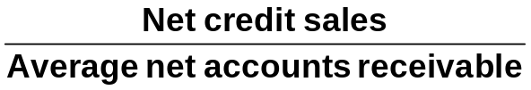

 | 2020 |  | 2019
(a) | 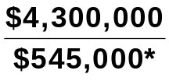 = 7.9 times |  | 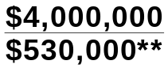 = 7.5 times
 | *($540,000 + $550,000) ÷ 2 |  | **($520,000 + $540,000) ÷ 2
(b) | Average collection period  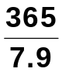 = 46.2 days |  | 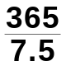 = 48.7 days

Colby Company can be somewhat pleased with the effectiveness of its credit and collection policies. The company has decreased the average collection period by more than two days and the collection period of approximately 46 days almost equals the 45 days allowed in the credit terms.
(Accts. rec. turnover = Net credit sales ÷ Ave. net accts. rec.); (2019: [$4,300,000 ÷ (($540,000 + $550,000) ÷ 2)]
(Ave. coll. period = Days in yr. ÷ Accts. rec. turnover); (2019: 365 ÷ 7.5)
LO 3 BT: AN Difficulty: Moderate TOT: 10 min. AACSB: Analytic and Communication AICPA FC: Measurement and Reporting AICPA PC: Communication IMA: FSA
BRIEF EXERCISE 18-12

(a) Inventory turnover = 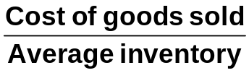

 | 2020 |  | 2019
 | 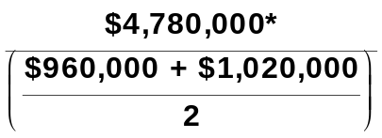 = 4.8 times |  | 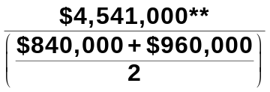 = 5.0 times
 |  |  | 2020 |  | 2019
 | Beginning inventory  Purchases  Goods available for sale  Ending inventory  Cost of goods sold |  | $ 960,000  4,840,000  5,800,000  1,020,000  $4,780,000* |  | $ 840,000  4,661,000  5,501,000  960,000  $4,541,000**
(Inv. turnover = CGS ÷ Ave. inv.); [2019: ($960,000 + $4,840,000 - $1,020,000) ÷ (($960,000 + $1,020,000) ÷ 2)]

(b) Days in inventory

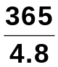 = 76 days 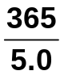 = 73 days

Management should be concerned with the fact that inventory moved more slowly in 2020 than it did in 2019. The decrease in inventory turnover could be because of poor pricing decisions or because the company is holding obsolete inventory.
(Days in inv. = Days in yr. ÷ Inv. turnover); (2019: 365 ÷ 5.0)
LO 3 BT: AN Difficulty: Hard TOT: 15 min. AACSB: Analytic and Communication AICPA FC: Measurement and Reporting AICPA PC: Communication IMA: FSA
BRIEF EXERCISE 18-13

(a) Asset turnover = 
= 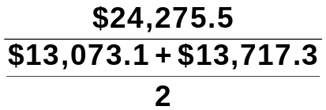
= 1.81 times

Staples generated $1.81 of sales for each dollar it had invested in assets.
(Asset turnover =Net sales ÷ Ave. tot. assets); [$24,275.5 ÷ (($13,073.1 + $13,717.3) ÷ 2)]

(b) Profit margin = 

= 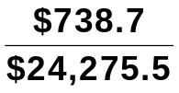

= 3.0%

Each dollar of sales resulted in about 3 cents of net income.
(Net inc. ÷ Net sales); ($738.7 ÷ $24,275.5)
LO 3 BT: AN Difficulty: Moderate TOT: 6 min. AACSB: Analytic AICPA FC: Measurement and Reporting IMA: FSA
BRIEF EXERCISE 18-14

Payout ratio = 

0.18 = 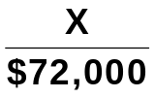

X = $72,000 (0.18) = $12,960

Cash dividends = $12,960
(Cash dividends = Net inc. × Payout ratio); ($72,000 x .18)
Return on assets = 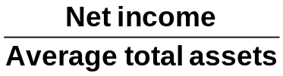

0.20 = 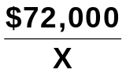

0.20X = $72,000

X = 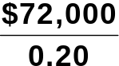

X = $360,000

Average total assets = $360,000
(Ave. tot. assets = Net inc. ÷ Return on assets); ($72,000 ÷ .20)
LO 3 BT: AN Difficulty: Hard TOT: 12 min. AACSB: Analytic AICPA FC: Measurement and Reporting IMA: FSA
BRIEF EXERCISE 18-15

 | Free Cash Flow | = Cash provided by operating activities –  Capital expenditures – Cash dividends
$10.4 – $3.7 – $6.2 = $0.5 million

Topps Company generated enough cash from operating activities to maintain its current productive capacity and pay dividends. The free cash flow that remained could have been used to expand operations, pay additional dividends, or reduce debt.
(Cash provided by oper. act. − Cap. expend. − Cash div.); ($10.4 - $3.7 - $6.2)
LO 3 BT: AN Difficulty: Easy TOT: 5 min. AACSB: Analytic AICPA FC: Measurement and Reporting IMA: FSA
SOLUTIONS TO DO IT! EXERCISES

DO IT! 18-1

HRABIK CORPORATION
Partial Statement of Comprehensive Income

Income before income taxes $500,000
Income tax expense 100,000
Income from continuing operations 400,000
Discontinued operations
Loss from operations of music
division, net of $12,000 income tax savings $48,000
Gain from disposal of music
division, net of $8,000 taxes 32,000 (16,000)
Net income 384,000
Other comprehensive income:
Unrealized holding loss of available-for-sale securities,
net of $30,000 income tax savings 120,000
Comprehensive income $264,000
(Inc. before inc. taxes – Inc. tax exp. – Discont. oper. – Other comp. inc.); [$500,000 - $100,000 – (($60,000 x (1 – 20%)) - ($40,000 x (1 – 20%)) – ($150,000 x (1 – 20%))]
LO 1 BT: AP Difficulty: Moderate TOT: 10 min. AACSB: Analytic AICPA FC: Reporting IMA: Reporting

DO IT! 18-2

Increase (Decrease) in 2020

Amount Percent
Current assets $ (20,000) (9.1)% [($ 200,000 – $ 220,000) ÷ $ 220,000]
Plant assets 260,000 33.3% [($1,040,000 – $ 780,000) ÷ $ 780,000]
Total assets $240,000 24.0% [($1,240,000 – $1,000,000) ÷ $1,000,000]
LO 2 BT: AP Difficulty: Easy TOT: 5 min. AACSB: Analytic AICPA FC: Measurement and Reporting IMA: FSA

DO IT! 18-3

2020 2019
(a) Current ratio:
$1,380 ÷ $900 = 1.53:1
$1,310 ÷ $790 = 1.66:1
(Current assets ÷ Current liabl)

(b) Inventory turnover:
$955/ [($460 + $390) ÷ 2)] = 2.25 times
$890/ [($390 + $340) ÷ 2)]= 2.44 times
(CGS ÷ Ave. inv.)

(c) Profit margin ratio:
$294 ÷ $3,800 = 7.7%
$154 ÷ $3,460 = 4.5%
(Net inc. ÷ Net sales)

(d) Return on assets:
$294/[($2,340 + $2,210) ÷ 2)] = 12.9%
$154/[($2,210 + $1,900) ÷ 2)] = 7.5%
(Net inc. ÷ Ave. tot. assets)

(e) Return on common stockholders’ equity:
$294/[($1,030 + $1,040) ÷ 2)] = 28.4%
$154/[$1,040 + $900) ÷ 2)] = 15.9%
(Net inc. ÷ Ave. com. stkhldrs’ equity)

(f) Debt to assets ratio:
($900 + $410) ÷ $2,340 = 56.0%
($790 + $380) ÷ $2,210 = 52.9%
(Tot. liabl. ÷ Tot. assets)

(g) Times interest earned:
($294 + $126 + $25) ÷ $25 = 17.8 times
($154 + $66 + $20) ÷ $20 = 12.0 times
[(Net inc. + Inc. tax. exp. + Int. exp.) ÷ Int. exp.]
LO 3 BT: AP Difficulty: Moderate TOT: 12 min. AACSB: Analytic AICPA FC: Measurement and Reporting IMA: FSA

SOLUTIONS TO EXERCISES

EXERCISE 18-1

(a)
HAAS CORPORATION
Partial Statement of Comprehensive Income
For the Year Ended October 31, 2020

Income before income taxes $540,000
Income tax expense ($540,000 x 20%) 108,000
Income from continuing operations 432,000
Discontinued operations
Loss from operations, net of $10,000
income tax savings ($50,000 x 20%) $40,000
Loss on disposal, net of $14,000
income tax savings ($70,000 x 20%) 56,000 96,000
Net income $336,000
(Inc. before inc. tax. – Inc. tax exp. – Discont. oper.); [$540,000 – ($540,000 x 20%) – (($50,000 x (1 – 20%)) + ($70,000 x (1 – 20%)))]

(b) To: Chief Accountant

From: Your name, Independent Auditor

After reviewing your income statement for the year ended October 31, 2020, we believe it is misleading for the following reasons:

The amount reported for income from continuing operations is overstated by $24,000. The income tax expense should be 20% of $540,000, or $108,000, not $84,000.

Also, the effect of the loss on discontinued operations on net income is only $96,000, not $120,000. An income tax savings of $24,000 should be netted against the loss.
LO 1 BT: AP Difficulty: Moderate TOT: 15 min. AACSB: Analytic and Communication AICPA FC: Measurement and Reporting AICPA PC: Communication IMA: Reporting

EXERCISE 18-2

TRAYER CORPORATION
Partial Statement of Comprehensive Income
For the Year Ended December 31, 2020

Income from continuing operations $290,000
Discontinued operations
Loss from operations, net of $2,000
income tax savings $ 8,000
Gain from disposal, net of $8,000
income taxes 32,000 24,000
Net income $314,000
Other comprehensive income
Unrealized holding loss on available-for-sale securities,
net of $16,000 income tax savings 64,000
Comprehensive income $250,000
(Inc. from contin. Oper. + Discont. oper. – other comp. inc.); [$290,000 + (((-$10,000 x (1 – 20%)) + (($40,000 x (1 – 20%))) – ($80,000 x (1 – 20%))]
LO 1 BT: AP Difficulty: Moderate TOT: 15 min. AACSB: Analytic and Communication AICPA FC: Measurement and Reporting AICPA PC: Communication IMA: Reporting

EXERCISE 18-3

GLITTER INC.
Condensed Balance Sheet
December 31

 |  |  |  |  |  | Increase or (Decrease)
 |  | 2020 |  | 2019 |  | Amount |  | Percentage
Assets
Current assets  Plant assets (net)  Total assets |  | $106,000  400,000  $506,000 |  | $ 90,000  350,000  $440,000 |  | ($16,000  50,000  ($66,000 |  | (17.8%)  (14.3%)  (15.0%)
Liabilities
Current liabilities  Long-term liabilities  Total liabilities |  | $ 99,000  122,000  221,000 |  | $ 65,000  90,000  155,000 |  | ($34,000  32,000  66,000 |  | (52.3%)  (35.6%)  (42.6%)
Stockholders’ Equity
Common stock, $1 par  Retained earnings  Total stockholders’  equity  Total liabilities and  stockholders’  equity |  | 130,000  155,000  285,000  $506,000 |  | 115,000  170,000  285,000  $440,000 |  | 15,000  (15,000)  –0–  ($66,000 |  | (13.0%)  (8.8%)  (–0–  (15.0%)
[Percent. change in 2020 current assets = (2020 amt. − 2019 amt.) ÷ 2019 amt.]; [($106,000 - $90,000) ÷ $90,000]
LO 2 BT: AP Difficulty: Moderate TOT: 15 min. AACSB: Analytic AICPA FC: Measurement and Reporting IMA: FSA
EXERCISE 18-4

JOSHUA CORPORATION
Condensed Income Statement
For the Years Ended December 31

 |  | 2020 |  |  |  | 2019
 |  | Amount |  | Percent |  | Amount |  | Percent
Sales revenue  Cost of goods sold  Gross profit  Selling expenses  Administrative expenses  Total operating expenses  Income before income taxes  Income tax expense  Net income |  | $800,000  520,000  280,000  120,000  60,000  180,000  100,000  30,000  $ 70,000 |  | 100.0%  65.0%  35.0%  15.0%  7.5%  22.5%  12.5%  3.7%  8.8% |  | $600,000  408,000  192,000  72,000  48,000  120,000  72,000  24,000  $ 48,000 |  | 100.0%  68.0%  32.0%  12.0%  8.0%  20.0%  12.0%  4.0%  8.0%
(2020 CGS percent. = CGS ÷ Sales rev.); ($520,000 ÷ $800,000)
LO 2 BT: AP Difficulty: Moderate TOT: 15 min. AACSB: Analytic AICPA FC: Measurement and Reporting IMA: FSA

EXERCISE 18-5

(a) NIKE, INC.
Condensed Balance Sheet
May 31
($ in millions)

 |  |  | 2020 |  | 2019 |  | Increase  (Decrease) |  | Percentage  Change  from 2019
 | Assets  Current assets  Property, plant, and  equipment (net)  Other assets  Total assets |  | $ 9,734  1,958  1,558  $13,250 |  | $ 8,839  1,891  1,713  $12,443 |  | $895  67  (155)  $807 |  | 10.1%  3.5%  (9.0)%  6.5%

EXERCISE 18-5 (Continued)

NIKE, INC.
Condensed Balance Sheet (Continued)
May 31

 |  |  | 2020 |  | 2019 |  | Increase  (Decrease) |  | Percentage  Change  from 2019
 | Liabilities and stock-  holders’ equity  Current liabilities  Long-term  liabilities  Stockholders’  equity  Total liabilities and  stockholders’  equity |  | $ 3,277  1,280  8,693  $13,250 |  | $ 3,322  1,296  7,825  $12,443 |  | $ (45)  (16)  868  $807 |  | (1.4%)  (1.2%)  11.1%  6.5%
[Percent. change in 2020 current assets = (2020 amt. – 2019 amt.) ÷ 2019 amt.]; [($9,734 - $8,839) ÷ $8,839]

(b) NIKE, INC.
Condensed Balance Sheet
May 31, 2020

 |  |  | $ (in millions) |  | Percent
 | Assets  Current assets  Property, plant, and equipment (net)  Other assets  Total assets  Liabilities and stockholders’ equity  Current liabilities  Long-term liabilities  Stockholders’ equity  Total liabilities and stockholders’ equity |  | $ 9,734  1,958  1,558  $13,250  $ 3,277  1,280  8,693  $13,250 |  | 73.5%  14.8%  11.7%  100.0%  24.7%  9.7%  65.6%  100.0%
(Current asset percent. = Current asset amt. ÷ Tot. asset amt.); ($9,734 ÷ $13,250)
LO 2 BT: AP Difficulty: Moderate TOT: 20 min. AACSB: Analytic AICPA FC: Measurement and Reporting IMA: FSA
EXERCISE 18-6

(a) DELANEY CORPORATION
Condensed Income Statement
For the Years Ended December 31

Increase or (Decrease)
During 2020
 |  |  | 2020 |  | 2019 |  | Amount |  | Percentage
 | Net sales  Cost of goods sold  Gross profit  Operating expenses  Net income |  | $598,000  477,000  121,000  80,000  $ 41,000 |  | $500,000  420,000  80,000  44,000  $ 36,000 |  | $98,000  57,000  (41,000)  36,000)  $ 5,000) |  | 19.6%  13.6%  (51.3%  81.8%  (13.9%

(b) DELANEY CORPORATION
Condensed Income Statements
For the Years Ended December 31

 |  |  | 2020 |  |  |  | 2019
 |  |  | $ |  | Percent |  | $ |  | Percent
 | Net sales  Cost of goods sold  Gross profit  Operating expenses  Net income |  | $598,000  477,000  121,000  80,000  $ 41,000 |  | 100.0%  79.8%  20.2%  13.4%  6.8% |  | $500,000  420,000  80,000  44,000  $ 36,000 |  | 100.0%  84.0%  16.0%  8.8%  7.2%
LO 2 BT: AP Difficulty: Moderate TOT: 15 min. AACSB: Analytic AICPA FC: Measurement and Reporting IMA: FSA

EXERCISE 18-7

Current ratio = 2.01:1 ($4,054 ÷ $2,014)
Accounts receivable turnover = 4.2 times ($8,258 ÷ $1,988.5ª)
Average collection period = 86.9 days (365 days ÷ 4.2)
Inventory turnover = 5.9 times ($5,328 ÷ $899^{b})
Days in inventory = 61.9 days (365 days ÷ 5.9)

ª($2,035 + $1,942) ÷ 2
^{b}($898 + $900) ÷ 2
(Accts. rec. turnover = Net credit sales ÷ Ave. accts. rec.); [$8,258 ÷ (($2,035 + $1,942) ÷ 2)]
(Inv. turnover = CGS ÷ Ave. inv.); [$5,328 ÷ (($898 + $900) ÷2)]

EXERCISE 18-7 (Continued)

LO 3 BT: AP Difficulty: Moderate TOT: 10 min. AACSB: Analytic AICPA FC: Measurement and Reporting IMA: FSA

EXERCISE 18-8

Current ratio as of February 1, 2020 = 3.00:1 ($120,000 ÷ $40,000).
Feb. 3 3.00 No change in total current assets or liabilities.
7 2.43 ($97,000 ÷ $40,000).
11 2.43 No change in total current assets or liabilities.
14 3.04 ($85,000 ÷ $28,000).
18 2.66 ($85,000 ÷ $32,000).
LO 3 BT: AP Difficulty: Hard TOT: 15 min. AACSB: Analytic AICPA FC: Measurement and Reporting IMA: FSA

EXERCISE 18-9

(a) Current ratio = 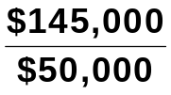 = 2.90:1
[(Cash + Accts. rec. + inv.) ÷ Accts. pay.]; [($15,000 + $70,000 + $60,000) ÷ $50,000]

(b) Accounts receivable turnover = 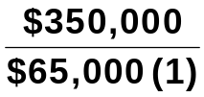 = 5.4 times

 | (1) | 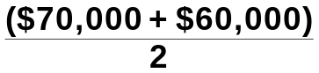
[(Sales – Sales returns & allow.) ÷ Ave. accts. rec.]; [($375,000 - $25,000) ÷ (($70,000 + $60,000) ÷ 2)]
(c) Average collection period = 365 days ÷ 5.4 = 67.6 days

(d) Inventory turnover = 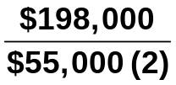 = 3.6 times

 | (2) | 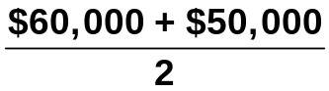
(CGS ÷ Ave. inv.); [$198,000 ÷ (($60,000 + $50,000) ÷ 2)]
(e) Days in inventory = 365 days ÷ 3.6 = 101.4 days

(f) Free cash flow = $48,000 – $25,000 – $10,000 = $13,000
(Net cash provided by oper. act. – Cap. expend. – Div. pd.); ($48,000 - $25,000 - $10,000)
LO 3 BT: AP Difficulty: Moderate TOT: 12 min. AACSB: Analytic AICPA FC: Measurement and Reporting IMA: FSA
EXERCISE 18-10

(a) Profit margin 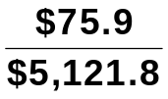 = 1.5%

(b) Asset turnover 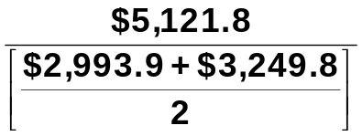 = 1.64 times

(Net sales ÷ Ave. tot. assets); [$5,121.8 ÷ (($2,993.9 + $3,249.8) ÷ 2)]

(c) Return on assets 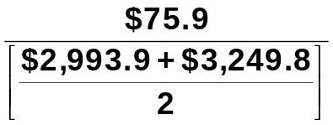 = 2.4%
(Net inc. ÷ Ave. tot. assets); [$75.9 ÷ (($2,993.9 + $3,249.8) ÷ 2)]

(d) | Return on common stockholders’ equity | 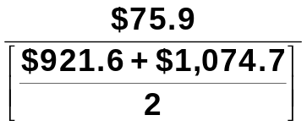 = 7.6%
(Net inc. ÷ Ave. com. stkhldrs’ equity); [$75.9 ÷ (($921.6 + $1,074.7) ÷)]

(e) Gross profit rate 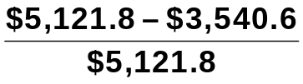 = 30.9%
LO 3 BT: AP Difficulty: Moderate TOT: 10 min. AACSB: Analytic AICPA FC: Measurement and Reporting IMA: FSA

EXERCISE 18-11

(a) Earnings per share 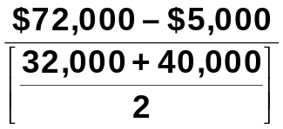 = 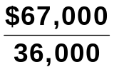 = $1.86
[ (Net inc. – pref. div.) ÷ Ave. number of com. shs. outstanding]; [($72,000 - $5,000) ÷ ((32,000 + 40,000) ÷ 2)]

(b) Price-earnings ratio 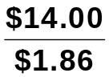 = 7.5 times

(c) Payout ratio 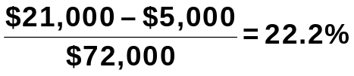
[(Tot. div. pd. – Pref. div.) ÷ Net inc.]; [($21,000 - $5,000) ÷ $72,000]

EXERCISE 18-11 (Continued)

(d) | Times interest  earned | 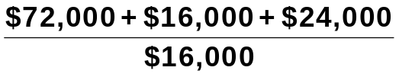 = 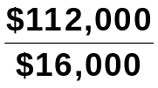 = 7.0 times
[(Net inc. + Int. exp. + Inc. tax exp.) ÷ Int. exp.]; [($72,000 + $16,000 + $24,000) ÷ $16,000]
LO 3 BT: AP Difficulty: Moderate TOT: 10 min. AACSB: Analytic AICPA FC: Measurement and Reporting IMA: FSA

EXERCISE 18-12

(a) Inventory turnover = 3.8 = 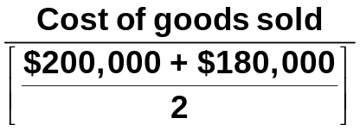

3.8 × $190,000 = Cost of goods sold
Cost of goods sold = $722,000.
(CGS = Ave. inv. x Inv. turnover); [(($200,000 + $180,000) ÷ 2) x 3.8]

(b) Accounts receivable turnover = 11.2 = 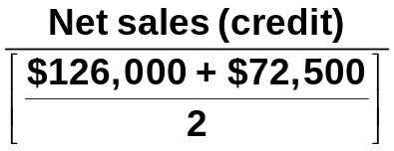

11.2 × $99,250 = Net sales (credit) = $1,111,600.
(Net sales (credit) = Ave. accts. rec. x accts. rec. turnover); [(($126,000 + $72,500) ÷ 2) x 11.2]

(c) Return on common stockholders’ equity = 22% =

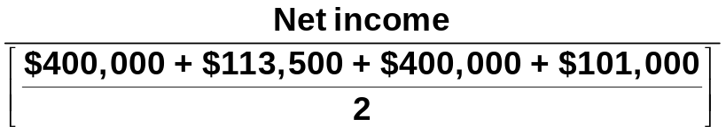

0.22 × $507,250 = Net income = $111,595.
(Net inc. = Ave. com. stkhldrs’ equity x Rtn. on com. stlhldrs’ equity); [(($400,000 + $113,500 + $400,000 + $101,000) ÷ 2) x .22]

(d) Return on assets = 18% = 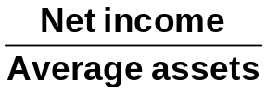 = 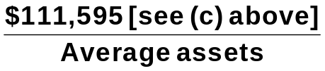

Average assets = 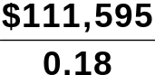 = $619,972

EXERCISE 18-12 (Continued)

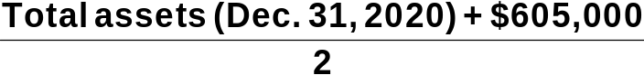 = $619,972

Total assets (Dec. 31, 2020) = ($619,972 × 2) – $605,000 = $634,944.
(Ave. assets = Net inc. ÷ Rtn. on assets); ($111,595 ÷ .18)
[Tot. assets, Dec. 31, 2020 = (Ave. assets x 2) – Tot. assets, Dec. 31, 2019]; [($619,972 x 2) - $605,000]
LO 3 BT: AN Difficulty: Hard TOT: 20 min. AACSB: Analytic AICPA FC: Measurement, Reporting IMA: FSA

EXERCISE 18-13
2020 2019
(a) Current ratio:
$1,390 ÷ $820 = 1.70:1
$1,310 ÷ $790 = 1.66:1

(b) Inventory turnover:
$970÷[($460 + $390) ÷ 2)] = 2.28
$890÷[($390 + $340) ÷ 2)] = 2.44
(CGS ÷ Ave. inv.); [2019 = $970 ÷ (($460 + $390) ÷ 2)]

(c) Profit margin:
$252 ÷ $3,800 = 6.6%
$132 ÷ $3,460 = 3.8%

(d) Return on assets:
$252÷[($2,340 + $2,210) ÷ 2)] = 11.1%
$132÷[($2,210 + $1,900) ÷ 2)] = 6.4%
(Net inc. ÷ Ave. tot. assets); [2019 = $252 ÷ (($2,340 + $2,210) ÷ 2)]

(e) Return on common stockholders’ equity:
$252÷[($1,040 + $1,040) ÷ 2)] = 24.2%
$132÷[($1,040 + $900) ÷ 2)] = 13.6%
(Net inc. ÷ Ave. com. stkhldrs’ equity); [2019 = $252 ÷ (($1,040 + $1,040) ÷ 2)]

(f) Debt to assets ratio:
($820 + $480) ÷ $2,340 = 55.6%
($790 + $380) ÷ $2,210 = 52.9%
(Tot. liabl. ÷ Tot. assets); [2020 = (($820 + $480) ÷ 2) ÷ $2,340]

(g) Times interest earned:
($252 + $168 + $10) ÷ $10 = 43 times
($132 + $88 + $20) ÷ $20 = 12 times
LO 3 BT: AP Difficulty: Moderate TOT: 20 min. AACSB: Analytic AICPA FC: Measurement and Reporting IMA: FSA

SOLUTIONS TO PROBLEMS

PROBLEM 18-1A

(a) Condensed Income Statement
For the Year Ended December 31, 2020

 |  |  | Duke Company |  |  |  | Lord Company
 |  |  | Dollars |  | Percent |  | Dollars |  | Percent
 | Net sales  Cost of goods sold  Gross profit  Operating expenses  Income from operations  Other expenses and losses  Interest expense  Income before income taxes  Income tax expense  Net income |  | $1,849,000  1,063,200  785,800  240,000  545,800  6,800  539,000  62,000  $ 477,000 |  | 100.0%  57.5%  42.5%  13.0%  29.5%  .4%  29.1%  3.3%  25.8% |  | $546,000  289,000  257,000  82,000  175,000  3,600  171,400  28,000  $143,400 |  | 100.0%  52.9%  47.1%  15.0%  32.1%  .7%  31.4%  5.1%  26.3%

(b) Lord Company appears to be more profitable. It has higher relative
gross profit, income from operations, income before taxes, and net in-
come. Also, Duke's return on assets of 57.3% 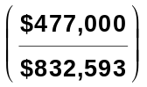ª is lower than Lord's return on assets of 67.0% 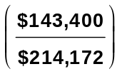^{b}, and Duke's return on common stockholders’ equity of 72.3% 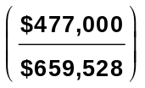^{c} is lower than Lord's return on common stockholders’ equity of 93.1% 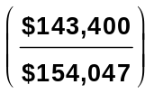^{d}.

PROBLEM 18-1A (Continued)

ª$477,000 is Duke's 2020 net income. $832,593 is Duke's 2020 average assets:

 |  |  | 2020 |  | 2019
 | Current assets  Plant assets  Total assets |  | $325,975  526,800  $852,775 | + | $312,410  500,000  $812,410 | = | 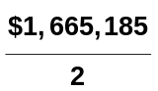

^{b}$143,400 is Lord's 2020 net income. $214,172 is Lord's 2020 average
ªassets:

 |  |  | 2020 |  | 2019
 | Current assets  Plant assets  Total assets |  | $ 83,336  139,728  $223,064 | + | $ 79,467  125,812  $205,279 | = | 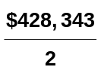

^{c}$477,000 is Duke's 2020 net income. $659,528 is Duke's 2020 average stockholders’ equity:

 |  |  | 2020 |  | 2019
 | Common stock  Retained earnings  Stockholders’ equity |  | $500,000  172,460  $672,460 | + | $500,000  146,595  $646,595 | = | 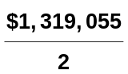

^{d}$143,400 is Lord's 2020 net income. $154,047 is Lord's 2020 average
^{d}stockholders’ equity:

 |  |  | 2020 |  | 2019
 | Common stock  Retained earnings  Stockholders’ equity |  | $120,000  38,096  $158,096 | + | $120,000  29,998  $149,998 | = | 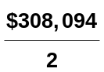

LO 2, 3 BT: AN Difficulty: Moderate TOT: 30 min. AACSB: Analytic and Communication AICPA FC: Measurement and Reporting AICPA PC: Communication IMA: Reporting and FSA

PROBLEM 18-2A

(a) Earnings per share = 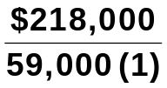 = $3.69

(1) 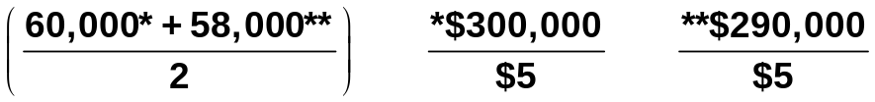

(b) Return on common stockholders’ equity = 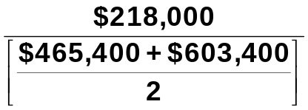

= 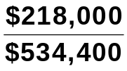

= 40.8%

(Net inc. ÷ Ave. com. stkhldrs’ equity); [ $218,000 ÷ (($465,400 + $603,400) ÷ 2)]
(c) Return on assets = 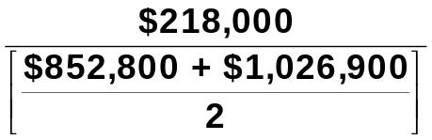 = 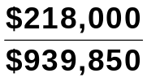 = 23.2%

(Net inc. ÷ Ave. tot. assets); [$218,000 ÷ (($852,800 + $1,026,900) ÷ 2)]

(d) Current ratio = 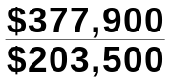 = 1.86:1

(e) Accounts receivable turnover = 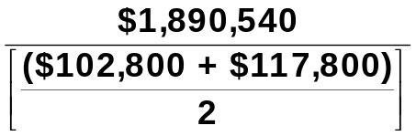
= 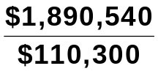 = 17.1 times
(Net credit sales ÷ Avg. accts. rec.); [$1,890,540 ÷ (($102,800 + $117,800) ÷ 2)]

PROBLEM 18-2A (Continued)

(f) Average collection period = 365 days ÷ 17.1 = 21.3 days

(g) Inventory turnover = 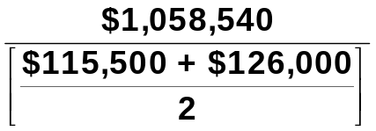 = 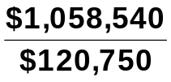 = 8.8 times

(CGS ÷ Ave. inv.); [$1,058,540 ÷ (($115,500 + $126,000) ÷ 2)]

(h) Days in inventory = 365 days ÷ 8.8 = 41.5 days

(i) Times interest earned = 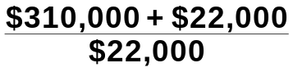 = 15.1 times

(j) Asset turnover = 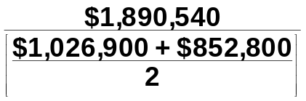 = 2.01 times

(Net sales ÷ Ave. tot. assets); [$1,890,540 ÷ (($1,026,900 + $852,800) ÷ 2)]

(k) Debt to assets ratio = 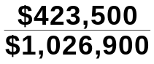 = 41.2%

(l) Free cash flow = $220,000 – $136,000 – $70,000 = $14,000

LO 3 BT: AP Difficulty: Moderate TOT: 30 min. AACSB: Analytic AICPA FC: Measurement and Reporting IMA: FSA

PROBLEM 18-3A

(a) |  | 2020 |  | 2019
 | (1) | Profit margin.  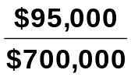 = 13.6% |  | 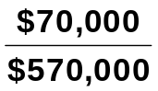 = 12.3%
 | (2) | Gross profit rate.  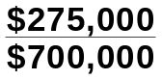 = 39.3% |  | 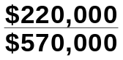 = 38.6%
 | (3) | Asset turnover.  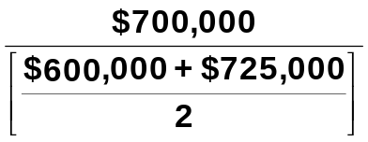 = 1.06 times |  | 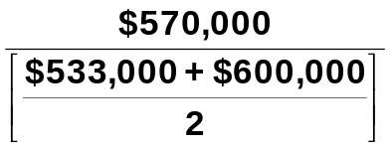 = 1.01 times
 |  | (Net Sales ÷ Ave. tot. assets); [2020 = $700,000 ÷ (($600,000 + $725,000 ÷ 2)]
 | (4) | Earnings per share.  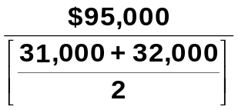 = $3.02 |  | 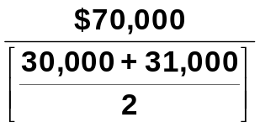 = $2.30
 |  | (Net inc. ÷ Ave. com. shs. outstanding); [2020 = $95,000 ÷((31,000 + 32,000) ÷ 2)]
 | (5) | Price-earnings ratio.  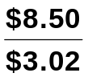 = 2.8 times |  | 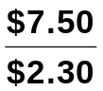 = 3.3 times
 | (6) | Payout ratio.  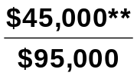 = 47%  **($125,000 + $95,000 – $175,000) |  | 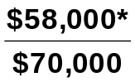 = 83%  *($113,000 + $70,000 – $125,000)
 |  | [2020 = (2019 ret. earn. + 2020 net inc. – 2020 ret. earn.) ÷ 2020 net inc.]; [($125,000 + $95,000 - $175,000) ÷ $95,000]
 | (7) | Debt to assets ratio.  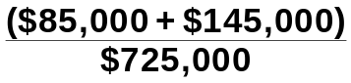 = 32% |  | 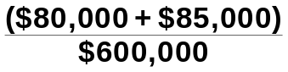 = 28%
PROBLEM 18-3A (Continued)

(Tot. liabl. ÷ Tot. assets); [(2019 = ($85,000 + $145,000) ÷ $725,000]

(b) The underlying profitability of the corporation appears to have improved. For example, profit margin and earnings per share have both increased. The corporation’s debt to assets ratio has increased but the improvements in profitability indicate that taking on more debt was a wise move.
LO 3 BT: AN Difficulty: Moderate TOT: 30 min. AACSB: Analytic and Communication AICPA FC: Measurement and Reporting AICPA PC: Communication IMA: FSA

PROBLEM 18-4A

(a) LIQUIDITY

 |  |  | 2019 |  | 2020 |  | % Change
 | Current  ratio |  | 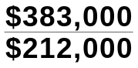 = 1.81:1 |  | 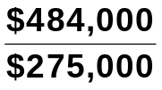 = 1.76:1 |  | (3%)
 | Accounts  receivable  turnover |  | 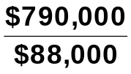 = 9.0 times |  | 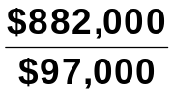 = 9.1 times |  | 1%
 |  | (Sales rev. ÷ Ave. accts. rec.); [ 2019 = $790,000 ÷ (($86,000 + $90,000) ÷ 2)]
 | Inventory  turnover |  | 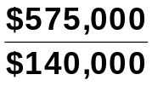 = 4.1 times |  | 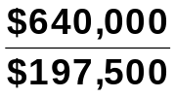 = 3.2 times |  | (22%)
 |  | (CGS ÷ Ave. inv.); [2019 = $575,000 ÷ (($115,000 + $165,000) ÷ 2)]

An overall decrease in short-term liquidity has occurred.

PROFITABILITY

 | Profit  margin |  | 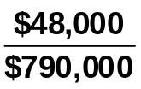 = 6.1% |  | 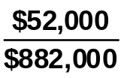 = 5.9% |  | (3%)
 | Asset  turnover |  | 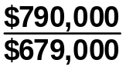 = 1.16 times |  | 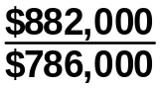 = 1.12 times |  | (3%)
 |  | (Net sales ÷ Ave. tot. assets); [2019 = $790,000 ÷ (($660,000 + $698,000) ÷ 2)]
 | Return on  assets |  | 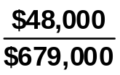 = 7.1% |  | 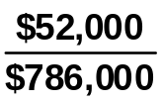 = 6.6% |  | (7%)
 |  | (Net inc. ÷ Ave. tot. assets); [2019 = $48,000 ÷ (($660,000 + $698,000) ÷ 2)]
 | Earnings  per share |  | 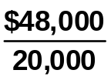 = $2.40 |  | 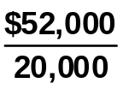 = $2.60 |  | 8%

Profitability has decreased slightly.

PROBLEM 18-4A (Continued)

(b) |  |  |  | 2020 |  | 2021 |  | %Change
 | 1. | Return on  common  stockhold-  ers’ equity |  | 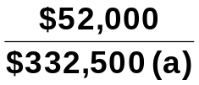 = 15.6% |  | 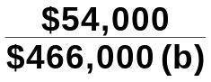 = 11.6% |  | (26%)
 |  | (Net inc. ÷ Ave. com. stkhldrs’ equity); [2021 = $54,000 ÷ (($200,000 + (18,000 x $10.sh.) + ($149,000 + $54,000) + $200,000 + $149,000) ÷ 2)]
 | 2. | Debt  to assets ratio |  | 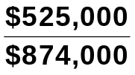 = 60% |  | 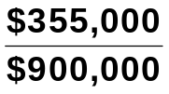 = 39% |  | (35%)
 |  | (Tot. liabl. ÷ Tot. assets); [2021 = ($65,000 + $40,000 + $250,000) ÷ $900,000]
 | 3. | Price-  earnings  ratio |  | 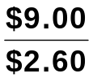 = 3.5 times |  | 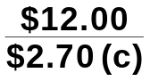 = 4.4 times |  | 26%
 |  | (Mkt. price per sh. ÷ EPS); [2021 = $12.00 ÷ ($54,000 ÷ 20,000)]

(a) ($200,000 + $149,000 + $200,000 + $116,000) ÷ 2.
(b) ($380,000* + $203,000** + $200,000 + $149,000) ÷ 2.
(c) $54,000 ÷ 20,000.

**$200,000 + (18,000 x $10/share)
**$149,000 + $54,000

LO 3 BT: AN Difficulty: Moderate TOT: 50 min. AACSB: Analytic AICPA FC: Measurement and Reporting IMA: FSA

PROBLEM 18-5A

(a) | Ratio |  | Target |  | Wal-Mart
 |  |  | (All Dollars Are in Millions)
 | (1) Current ratio  (2) Accounts receivable  turnover  (3) Average collection  period (in days)  (4) Inventory turnover  (5) Days in inventory  (6) Profit margin  (7) Asset turnover  (8) Return on assets  (9) Return on common  stockholders’ equity  (10) Debt to assets ratio  (11) Times interest earned  (12) Free cash flow |  | 1.63:1 ($18,424 ÷ $11,327)  8.7 ($65,357 ÷ $7,525)  42.0 (365 ÷ 8.7)  6.6 ($45,583 ÷ $6,942)  55.3 (365 ÷ 6.6)  3.8 % ($2,488 ÷ $65,357)  1.5 ($65,357 ÷ $44,319.5ª)  5.6 % ($2,488 ÷ $44,319.5ª)  17.1 % ($2,488 ÷ $14,529.5^{b})  66.0 % ($29,186 ÷ $44,533)  6.5 ($4,579^{c} ÷ $707)  $3,656 ($5,881 – $1,729 – $496) |  | .87:1 ($48,331 ÷ $55,561)  101.4 ($408,214 ÷ $4,025)  3.6 (365 ÷ 101.4)  9.0 ($304,657 ÷ $33,836)  40.6 (365 ÷ 9.0)  3.5% ($14,335 ÷ $408,214)  2.4 ($408,214 ÷ $167,067.5^{d})  8.6% ($14,335 ÷ $167,067.5^{d})  21.0% ($14,335 ÷ $68,369e)  58% ($99,650 ÷ $170,706)  11.4 ($23,539^{f} ÷ $2,065)  $9,848 ($26,249 – $12,184 – $4,217)

ª($44,533 + $44,106) ÷ 2 ^{d}($170,706 + $163,429) ÷ 2
^{b}($15,347 + $13,712) ÷ 2 ^{e}($71,056 + $65,682) ÷ 2
^{c}($2,488 + $1,384 + $707) ^{f}($14,335 + $7,139 + $2,065)

(b) The comparison of the two companies shows the following:

Liquidity—Target’s current ratio of 1.63:1 is better than Wal-Mart’s .87:1. However, Wal-Mart has a better inventory turnover than Target and its accounts receivable turnover is significantly better than Target’s.

Solvency—Wal-Mart betters Target in all of the solvency ratios. Thus, it is more solvent than Target.

Profitability—With the exception of profit margin, Wal-Mart betters Target in all of the profitability ratios. Thus, it is more profitable than Target.
LO 3 BT: AN Difficulty: Moderate TOT: 60 min. AACSB: Analytic and Communication AICPA FC: Measurement and Reporting AICPA PC: Communication IMA: FSA

CT 18 ETHICS CASE

(a) The stakeholders in this case are:
René Kelly, president of RL Industries.
Erin Lourdes, public relations director.
You, as controller of RL Industries.
Stockholders of RL Industries.
Potential investors in RL Industries.
Any readers of the press release.

(b) The president’s press release is deceptive and incomplete and to that extent her actions are unethical.

(c) As controller you should at least inform Erin, the public relations
director, about the biased content of the release. She should be aware that the information she is about to release, while factually accurate, is deceptive and incomplete. Both the controller and the public relations director (if she agrees) have the responsibility to inform the president of the bias of the about-to-be-released information.
LO 3 BT: E Difficulty: Moderate TOT: 20 min. AACSB: Analytic, Communication and Ethics AICPA FC: Reporting AICPA PC: Communication and Professional Demeanor IMA: Business Applications

CT 18-1 FINANCIAL REPORTING PROBLEM

(a) APPLE, INC.
Trend Analysis of Net Sales and Net Income
For the Three Years Ended 2015

Base Period 2013—(in millions)

 |  |  |  | 2015 |  | 2014 |  | 2013
 | (1) | Net sales  Trend |  | $233,715  137% |  | $182,795  107% |  | $170,910  100%
 | (2) | Net income  Trend |  | 53,394  144% |  | 39,510  107% |  | 37,037  100%

Between 2013 and 2015 Apple’s net sales increased by 37%. Apple’s net income increased by 7% between 2013 and 2014 and increased by almost 44% from 2013 to 2015.

(b) (dollar amounts in millions)

(1) Profit Margin

2015: $53,394 ÷ $233,715 = 22.8%
2014: $39,510 ÷ $182,795 = 21.6%

(2) Asset Turnover

2015: $233,715 ÷ [($290,479 + $231,839) ÷ 2] = 0.89 times
2014: $182,795 ÷ [($231,839 + $207,000) ÷ 2] = 0.83 times

(3) Return on Assets

2015: $53,394 ÷ [($290,479 + $231,839) ÷ 2] = 20.4%
2014: $39,510 ÷ [($231,839 + $207,000) ÷ 2] = 18.0%

CT 18-1 (Continued)

(4) Return on Common Stockholders’ Equity

2015: $53,394 ÷ [($119,355 + $111,547) ÷ 2] = 46.2%
2014: $39,510 ÷ [($111,547 + $123,549) ÷ 2] = 33.6%

Apple’s profitability has increased from 2014 to 2015 based on all of the measures of profitability.

(c) (dollar amounts in millions)

(1) Debt to Assets ratio

2015: $171,124 ÷ $290,479 = 58.9%
2014: $120,292 ÷ $231,839 = 51.9%

(2) Times Interest Earned

2015: ($53,394 + $19,121 + $733) ÷ $733 = 99.9 times
2014: ($39,510 + $13,973 + $384) ÷ $384 = 140.3 times.
Apple’s debt to assets ratio increased by more than 13%, which is a negative sign for solvency. Apple very easily has the ability to pay the interest on its debt as indicated by the times interest earned ratio for both years is at least 100 times.

(d) Substantial amounts of important information about a company are not in its financial statements. Events involving such things as industry changes, management changes, competitors’ actions, technological developments, governmental actions, and union activities are often critical to the successful operation of a company. Financial reports in the media and publications of financial service firms (Standard & Poors, Dun & Bradstreet) will provide relevant information not usually found in the annual report.
LO 2, 3 BT: AN Difficulty: Hard TOT: 60 min. AACSB: 60 min. AACSB: Analytic and Communication AICPA FC: Measurement and Reporting AICPA PC: Communication IMA: FSA

CT 18-2 COMPARATIVE ANALYSIS PROBLEM

(a) |  |  |  |  |  | PepsiCo |  |  |  |  | Coca-Cola Company
 | (1) | (i) | Percentage increase (decrease) in net sales |  |  | $63,056 − $66,683 |  | = (5.4%) |  |  | $44,294 − $45,998 |  | = (3.7%)
 |  |  |  |  |  | $66,683 |  |  |  |  | $45,998 |  | = (3.7%)
 |  | (ii) | Percentage increase  (decrease) in net  income |  |  | $5,452 − $6,513 |  |  | = (16.3%) |  | $7,351− $7,098 |  | = 3.6%
 |  |  |  |  |  | $6,513 |  |  | = (16.3%) |  | $7,098 |  | = 3.6%
 | (2) | (i) | Percentage increase  (decrease) in total assets |  |  | $69,667 − $70,509 |  |  | = (1.2%) |  | $90,093 − $92,023 |  | = (2.1%)
 |  |  |  |  |  | $70,509 |  |  | = (1.2%) |  | $92,023 |  | = (2.1%)
 |  | (ii) | Percentage increase  (decrease) in total common stockholders’ equity |  |  | $12,068 − $17,578 |  |  | = (31.3%) |  | $25,554 − $30,230 |  | = (15.5%)
 |  |  |  |  |  | 17,578 |  |  | = (31.3%) |  | $30,230 |  | = (15.5%)
 | (3) | Basic earnings per share* |  |  |  | $3.71 |  |  |  |  | $1.69
 |  | Price-earnings ratio |  |  |  | $103.41 | = 27.9 times |  |  |  | $42.63 | = 25.2 times
 |  |  |  |  |  | $3.71 |  |  |  |  | $1.69

*Given on income statement

(b) PepsiCo’s net sales decreased 5.4% while Coca-Cola’s decreased 3.7%. PepsiCo’s net income decreased 16.3% while Coca-Cola’s net income increased 3.6% from 2014 to 2015. PepsiCo’s total assets decreased 1.2% while Coca-Cola decreased its assets 2.1%.

PepsiCo’s stockholders’ equity decreased by 31.3% while Coca-Cola’s stockholders’ equity decreased 15.5%. The absolute amounts of earnings per share, $3.71 for PepsiCo and $1.69 for Coca-Cola, are not comparable in a qualitative way since these amounts are dependent on the number of shares outstanding. PepsiCo’s higher price-earnings ratio suggests that investors are more optimistic about PepsiCo than Coca-Cola.
LO 2, 3 BT: AN Difficulty: Moderate TOT: 30 min. AACSB: 60 min. AACSB: Analytic and Communication AICPA FC: Measurement and Reporting AICPA PC: Communication IMA: FSA

CT18-3 COMPARATIVE ANALYSIS PROBLEM

(a) |  |  |  |  | Amazon |  |  |  | Wal-Mart
 | (1) | (i) | Percentage increase  in net sales |  | $79,268 − $70,080 | = 13.1% |  |  | $478,614 − $482,229 | = (0.75%)
 |  |  |  |  | $70,080 |  |  |  | $482,229 | = (0.75%)
 |  | (ii) | Percentage increase  (decrease) in net  income |  | If the base year amount is zero or negative, a percentage change cannot be calculated. |  |  |  | $14,694 − $16,363 | = (10.2%)
 |  |  |  |  |  |  |  |  | $16,363 | = (10.2%)
 | (2) | (i) | Percentage increase  (decrease) in total assets |  | $65,444 − $54,505 |  | = 20.1% |  | $199,581 − $203,490 | = (1.9%)
 |  |  |  |  | $54,505 |  | = 20.1% |  | $203,490 | = (1.9%)
 |  | (ii) | Percentage increase  (decrease) in total stockholders’ equity |  | $13,384 − $10,741 |  | = 24.6% |  | $80,546 − $81,394 | = (1.0%)
 |  |  |  |  | $10,741 |  | = 24.6% |  | $81,394 | = (1.0%)
 | (3) | Basic earnings per share |  |  | $1.28* |  |  |  | $4.58*

Price-earnings ratio $398.79 ÷ $1.28 = 311.6 times $74.68 ÷ $4.58 = 16.3 times
*Given on income statement

(b) Amazon’s net sales increased 13.1% while Wal-Mart’s decreased 0.75%. Amazon’s net income increased significantly while Wal-Mart’s net income decreased 10.2% from FY 2014 to FY 2015. Amazon’s total assets increased 20.1% while Wal-Mart decreased its assets 1.9%.
Amazon increased stockholders’ equity by 24.6% while Wal-Mart’s stockholders’ equity decreased 1.0%. The absolute amounts of earnings per share, $1.28 for Amazon and $4.58 for Wal-Mart, are not comparable in a qualitative way since these amounts are dependent on the number of shares outstanding. The large difference in price-earnings ratios indicates that investors are significantly more optimistic about Amazon’s future earnings than Wal-Mart’s.
LO 2, 3 BT: AN Difficulty: Moderate TOT: 30 min. AACSB: 60 min. AACSB: Analytic and Communication AICPA FC: Measurement and Reporting AICPA PC: Communication IMA: FSA

CT 18-4 DECISION MAKING ACROSS THE ORGANIZATION

(a) Lenders prefer that financial statements are audited because an audit gives independent assurance that the financial statements give a reasonable representation of the company’s financial position and results of operations. With this independent assurance, they feel more comfortable making a decision.

(b) The current ratio increase is a favorable indication as to liquidity but alone tells little about the going-concern prospects of the client. From this ratio change alone, it is impossible to know the amount and direction of the changes in individual accounts, total current assets, and total current liabilities. Also unknown are the reasons for the changes.

The change in asset turnover cannot alone tell anything about either solvency or going-concern prospects. There is no way to know the amount and the direction of the changes in the two items. An increase in sales would be favorable for going-concern prospects, while a decrease in assets could represent a number of possible scenarios and would need to be investigated further.

The increase in net income is a favorable indicator for both solvency and going-concern prospects although much depends on the quality of receivables generated from sales and how quickly they can be converted into cash. Indirectly, the improved income picture may have a favorable impact on solvency and going-concern potential by enabling the client to borrow currently to meet cash requirements.

The 32 percent [($3.30 – $2.50) ÷ $2.50] increase in earnings per share, which is identical to the percentage increase in net income, is an indication there has probably been no change in the number of shares of common stock out standing. This, in turn, indicates that financing was not obtained through the issuance of common stock. It is not possible to reach conclusions about solvency and going-concern prospects without additional information about the nature and extent of financing.

The collective implications of these data alone are that the client entity is about as solvent and viable as a going concern at the end of the current year as it was at the beginning although there may be a need for short-term operating cash.
CT18-4 (Continued)

Although a quick evaluation of a reporting entity can be made using only a few ratios and comparing these with past ratios and industry statistics, the creditors should realize the limitations of such analysis even from the best prepared statements carrying a CPA’s unqualified opinion.

A limitation on comparisons with industry statistics or other companies within the industry exists because material differences can be created through the use of alternative (but acceptable) accounting methods. Further, when evaluating changes in ratios or percentages, the evaluation should be directed to the nature of the item being evaluated because very small differences in ratios or percentages can represent significant changes in dollar amounts or trends.

The creditors should evaluate conclusions drawn from ratio analysis
in light of the current status of, and expected changes in, such things
as general economic conditions, the client’s competitive position, the public’s demand (for the product itself, increased quality of the product, control of noise and pollution, etc.), and the client’s specific plans.

(c) 1. Accounts receivable turnover—indicates liquidity.
2. Debt to assets ratio—indicates solvency.
3. Times interest earned—indicates ability to repay interest when due.
Other answers are possible.
LO 3 BT: E Difficulty: Hard TOT: 60 min. AACSB: Analytic and Communication AICPA FC: Measurement and Reporting AICPA PC: Interaction, Leadership and Communication IMA: FSA

CT 18-5 REAL-WORLD FOCUS

(a), (b), and (c) Answers will vary depending on the company and the year chosen by the student.

LO 3 BT: AN Difficulty: Hard TOT: 60 min. AACSB: Analytic, Technology and Communication AICPA FC: Measurement and Reporting AICPA PC: Communication IMA: FSA

CT 18-6 REAL-WORLD FOCUS

(a) When a company does a stock split, its share price drops accordingly. If Amazon had not engaged in past stock splits its stock price at the time of the article would have been $1,166.
(b) Amazon dramatically increased its capacity to handle customer orders through its spending on fulfillment centers. However, until its sales increase enough to absorb this additional capacity, the company’s return on assets will probably suffer. First, the increase in plant assets will increase the company’s depreciation expense and reduce net income. Second, increasing plant assets increases the denominator of the return on assets, which reduces the company’s return.
(c) At the time of the article, Amazon’s P/E ratio was 76. Apple had a P/E ratio of 11.4, Netflix was 38 and the article says that Amazon’s was 3 1/2 times that of Wal-Mart, making it approximately 21.7. Amazon’s high value suggests that investors were expecting significant growth in Amazon’s earnings in future years.
(d) The article notes that Amazon’s 2012 operating margin was about half what it had been in the typical previous year. In the past, many of Amazon’s customers did not pay sales taxes on their purchases, which effectively gave Amazon a price advantage over traditional “brick and mortar” stores that do collect sales taxes. It stated that, because Amazon’s customers might have to start paying sales taxes on their purchases, Amazon might have to reduce its prices in order to continue to compete on price. This would reduce its profitability.
LO 3 BT: E Difficulty: Hard TOT: 60 min. AACSB: Analytic, Technology and Communication AICPA FC: Measurement and Reporting AICPA PC: Communication IMA: FSA

CT 18-7 COMMUNICATION ACTIVITY

To: Larry Dundee

From: Accounting Student

Re: Financial Statement Analysis

There are two fundamental considerations in financial statement analysis:
(1) the bases of comparison and (2) the limitations of financial statement analysis. Each of these considerations is explained below.

1. Bases of comparison. The bases of comparison are:

a. Intracompany—This basis compares an item or financial relationship within a company in the current year with the same item or relationship in one or more prior years.

b. Intercompany—This basis compares an item or financial relationship of one company with the same item or relationship in one or more competing companies.

c. Industry averages—This basis compares an item or financial relationship of a company with industry averages (or norms).

2. Three factors that affect quality of earnings are:

a. Alternative accounting methods—Variations among companies in the application of generally accepted accounting principles (GAAP) can cause variation in earnings quality across companies.

b. Pro forma income—Many companies now report non-GAAP income measures in addition to GAAP income. There is little guidance regarding these measures, thus the earnings quality of these measures is difficult to determine.

c. Improper recognition—In order to meet earnings targets, some companies record revenues and expenses in the wrong period. This directly reduces earnings quality.

LO 1, 2 BT: C Difficulty: Moderate TOT: 30 min. AACSB: Analytic and Communication AICPA FC: Measurement and Reporting AICPA PC: Communication IMA: Reporting

CT 18-8 ALL ABOUT YOU

Student responses will vary. We suggest that in class you ask for a few students to share their responses in order to increase students understanding of the reasons why different people will choose different investment vehicles.

LO N/A BT: AN Difficulty: Easy TOT: 20 min. AACSB: Analytic and Technology AICPA FC: Reporting IMA: Reporting

CT 18-9 FASB CODIFICATION ACTIVITY

(a) Discontinued Operations

205-20-45-1 The results of operations of a component of an entity that either has been disposed of or is classified as held for sale under the requirements of paragraph 360-10-45-9, shall be reported in discontinued operations in accordance with paragraph 205-20-45-3 if both of the following conditions are met:

a. The operations and cash flows of the component have been (or will be) eliminated from the ongoing operations of the entity as a result of the disposal transaction.

b. The entity will not have any significant continuing involvement in the operations of the component after the disposal transaction.

(b) Comprehensive Income

The change in equity (net assets) of a business entity during a period from transactions and other events and circumstances from nonowner sources. It includes all changes in equity during a period except those resulting from investments by owners and distributions to owners.

LO 1 BT: S Difficulty: Moderate TOT: 20 min. AACSB: Analytic and Technology AICPA FC: Reporting IMA: Reporting

IFRS 18-1 INTERNATIONAL FINANCIAL REPORTING PROBLEM

(All amounts are in millions of €)

(a) The company’s profit margin for 2015 was 10% (€3,573 ÷ €35,664), down from 18.4% (€5,648 ÷ €30,638) in 2014.

(b) Operating profit for 2015 was €6,384.

(c) Other comprehensive gains and losses was a net increase of €69.

LO 4 BT: AN Difficulty: Moderate TOT: 15 min. AACSB: Analytic, Communication and Diversity AICPA FC: Measurement and Reporting AICPA PC: Communication AICPA BB: International IMA: Global Business

